RIVET FITTING INSTRUCTION

1/BLOCK AND PUNCH 2/PLACE MALE RIVET IN HOLE
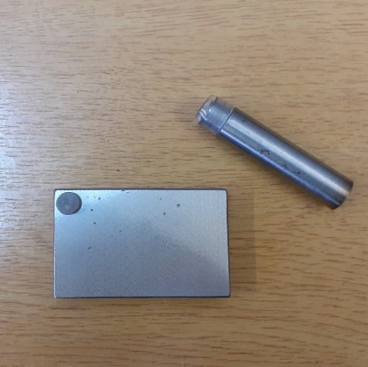
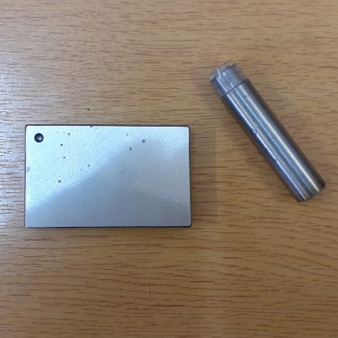

3/ PUSH PUNCH HARD ONTO 4/ FIRMLY ATTACHED
RIVET UNTIL RIVET IS SQUARELY
ATTACHED
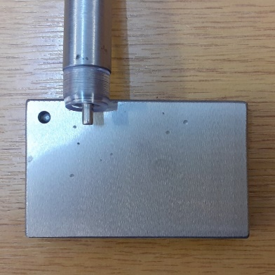
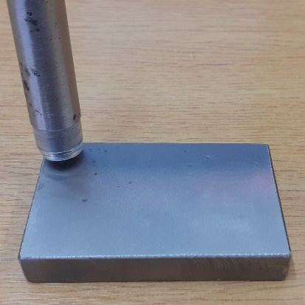

5/ PLACE FEMALE RIVET AS SHOWN 6/ PLACE STRAP ONTO BLOCK AND KEY
ONTO STRAP
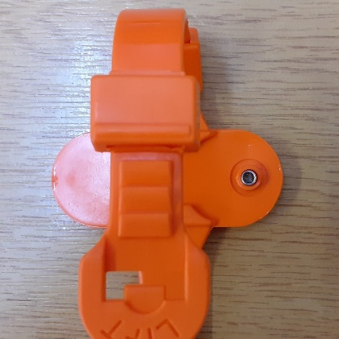
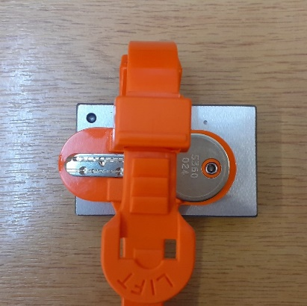

7/ HOLD PUNCH SQUARE AND HAMMER RIVET INTO PLACE
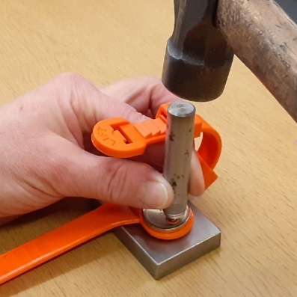

PLEASE USE A BLOCK OF WOOD ON A HARD SURFACE TO HAMMER RIVET INTO PLACE

